Comparison between dissolved chemical contents from samples collected by the osmosis-based water samplers and the benthic fluid flow CAT meter

OOI Data Quality report (OSMOIA301, OSMOIA101, FLOBNC101)

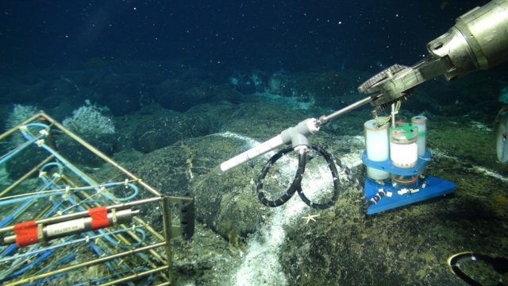

2018/8/3

Man-Yin Tsang

Dept. of Earth Sciences

University of Toronto

(Images on the cover page: left – osmosis-based water sampler (OOI, 2018a); right – benthic fluid flow CAT meter (Tryon, 2013))

### Review Summary

This report examines the quality of data from the osmosis-based water samplers (OSMOIA301, OSMOIA101) and the benthic fluid flow CAT meter (FLOBNC101) of the Ocean Observatories Initiative (OOI). Here includes a review of the easiness to access the data and the availability of supporting information, and a manual check on the data quality of the measured concentrations of dissolved chemicals in water samples from the two instruments.

Both instruments continuously collected and stored water samples which were analyzed in laboratories after retrieval. Multiple steps are carried out in this report to evaluate the quality of such chemical data:

* assess availability of data and information associated with the instruments;
* locate the instruments and identify the deployment periods;
* evaluate the quality of OSMOIA301 data at the ASHES Vent Field by comparing results to seawater and hydrothermal fluid;
* compare OSMOIA301 and OSMOIA101 to assess the consistency of the instrument; and
* evaluate data quality from FLOBNC101 by comparing its results to the nearby OSMOIA101

This report presents how additional information will better assist users who are not familiar with the two instruments to understand and interpret results from vent and seep fluid. The 2014-2015 deployment of OSMOIA301 captured mostly seawater instead of vent fluid. The first few samples of OSMOIA301 were more diluted than the rest of the samples but this phenomenon was not observed in OSMOIA101. At the Southern Hydrate Ridge, FLOBNC101 and OSMOIA101 were close to each other so their water samples were expected to have similar compositions. However, data from the two instruments showed markedly different concentrations of calcium and barium. It is so far inconclusive which instrument performs better for water sampling.

This report is prepared by the author during the OOI Early Career Data Workshop – Chemistry (July 30 – Aug 3, 2018). This report reflects how a user navigates through the OOI website and evaluates chemical data from the two types of instruments. Documents addressing the author’s doubts may be available somewhere but they could not be located by the author in a week’s time. Based on the author’s experience, suggestions are made at the end of each section in the hope to enhance the accessibility, credibility and user-friendliness of the OOI chemical data.

Table 1. Instruments evaluated

|  |  |  |
| --- | --- | --- |
| **Site** | **Instrument** | **Reference Designator** |
| ASHES Vent Field | Osmosis-based water sampler | RS03ASHS-MJ03B-00-OSMOIA301 |
| Southern Hydrate Summit 2 Seafloor | Osmosis-based water sampler | RS01SUM2-MJ01B-00-OSMOIA101 |
| Benthic Fluid Flow CAT meter | RS01SUM2-MJ01B-00-FLOBNC101 |

### Access Data of the Instruments

Data from OSMOIA301, OSMOIA101 and FLOBNC101 are available in raw data repositories instead of the OOI Data Portal. For chemical analysis, it is important that measurements have high accuracies and precisions. Thus the first step of this evaluation is to identify whether information important for quality assurance and control (QA/QC) is available to users.

Table 2: Whether documents of QA/QC of the instruments are available in the OOI website

|  |  |  |  |  |  |  |
| --- | --- | --- | --- | --- | --- | --- |
| **Instrument** | **DPS for the chemical data** | **Journal article/ Manual** | **Methods of sampling and analysis** | **Calibration records** | **Standard deviations of measurements** | **Annotations** |
| OSMOIA101,  OSMOIA301 | NA | Only simple descriptions | Yes, (ICP-OES & ICP-MS) | NA | Available | Hand-written |
| FLOBNC101 | NA | Yes | Yes, (ICP-OES) | NA | NA | Hand-written |

NA: not available

Suggestions:

* provide documents explaining the principles and test results of the osmosis-based water samplers;
* provide calibration records for ICP-OES and ICP-MS;
* provide error bars for measurements from FLOBNC101 using ICP-OES;
* provide typed annotations;
* include storage conditions, e.g., how and for how long the samples were stored until they were analyzed, the storage temperature; and
* it is understandable that the analysis of samples with ICP-OES or ICP-MS require laboratory work and additional manpower. If there is a moratorium period in which the data are not available to the public, please specify. Data from the 2015 deployment (or after) are still not available.

### Instrument locations and deployment periods

Users need to pinpoint the location and understand the surrounding environment of each instrument. Later sections in this report aim to compare data from OSMOIA101 and FLOBNC101 so it is essential to first confirm if the two instruments were close and sampling very similar fluid.

The latitude, longitude and water depth of each instrument during deployment were found in the OOI Data Team website. Compared to the OOI website which only presents the planned location of each instrument, the OOI Data Team website records the actual location of deployment. Surprisingly, osmosis-based water samplers from two different sites have the same record of lat/long. There is a mistake in the lat/long of OSMOIA101 which should locate at the Southern Hydrate Summit 2 Seafloor but the recorded lat/long is at the ASHES Vent Field.

Table 3. Location of each instrument from the OOI Data Team. Errors identified are underlined.

|  |  |  |  |  |  |  |
| --- | --- | --- | --- | --- | --- | --- |
| **Site** | **Instrument** | **Ref. Designator** | **Water depth (m)** | **Lat** | **Long** | **Periods of deployment** |
| ASHES Vent Field | Osmosis-based water sampler | RS03ASHS-MJ03B-00-OSMOIA301 | 1,541 | 45.9337 | -130.014 | 28 Sep 2014 to 8 Jul 2015a |
| Southern Hydrate Summit 2 Seafloor | Osmosis-based water sampler | RS01SUM2-MJ01B-00-OSMOIA101 | 774 | 45.9337b | -130.014 b | 9 Jul 2015 to presentc |
| Benthic Fluid Flow CAT meter | RS01SUM2-MJ01B-00-FLOBNC101 | 775 | 44.57 | -125.147 | 14 Jul 2015 to 22 Jul 2016, 23 Jul 2016 to presentd |

a: should be from 28 Jul 2014 to 8 Jul 2015 according to the dataset and the cruise report

b: the instrument was at Southern Hydrate Summit 2 but the lat/long is the same as OSMOIA301. Cruise report TN313 records the location as 44° 34.1928'N, 125° 08.8081'W, 772m depth

c. Dataset is from 2 Sep 2014 to 6 Jul 2015

d: Datasets are from 14 Jul 2013 to 30 Aug 2014, and from 8 Sept 2014 to 15 Jul 2015

The most helpful information showing the actual location of OSMOIA101 is a map and a photo with OSMOIA101 and FLOBNC101 in the TN326 cruise plan. They show that the two instruments were adjacent to each other on Southern Hydrate Summit 2. Therefore, we can expect the two instruments to sample fluid of similar compositions.



Fig 1. Locations of OSMOIA101 and FLOBNC101 (FLOBN-CAT in the image) in the TN326 cruise plan (University of Washington, 2015)



Fig. 2 An enlargement of the bottom part of Fig. 1 (University of Washington, 2015). OSMOIA101 and FLOBNC101 are about 5 m apart



Fig. 3. A photo showing that OSMOIA101 (2nd right) and FLOBNC101 (2nd left) were close to each other in the 2014 deployment (University of Washington, 2015). Fluid samples from the two instruments were expected to be similar

Suggestions:

* include explanations that the OOI Data Portal only shows the planned locations of instruments while the OOI Data Team website shows the actual locations;
* check locations of instruments and whether the recorded periods of deployment match the time in the datasets; and
* photos of instruments on-site are very helpful for the interpretation of sampling locations and environments

### Evaluate OSMOIA301 at the ASHES Vent Field

OSMOIA301 was located at the ASHES Vent Field. Fluid passed through OSMOIA301 could be a mixture of seawater and hydrothermal fluid. Here measurements from ICP-OES on OSMOIA301 water samples (short-coiled) are plotted against seawater values (standard seawater of International Association for the Physical Sciences of the Ocean, IAPSO; except for barium concentration the seawater value is from the bottom water reported by the data collector).

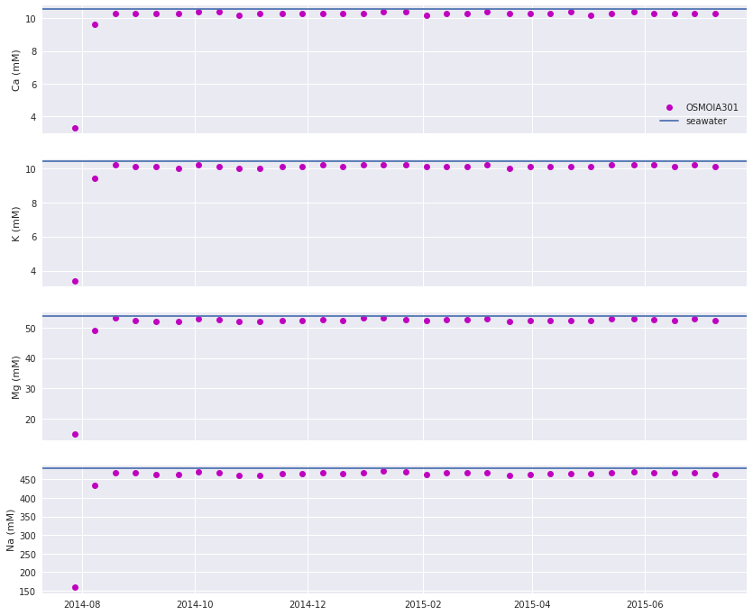

Fig. 4. Calcium, potassium, magnesium and sodium contents in water samples collected by OSMOIA301. The first two samples record low concentrations. From the third sample onwards concentrations resemble seawater values

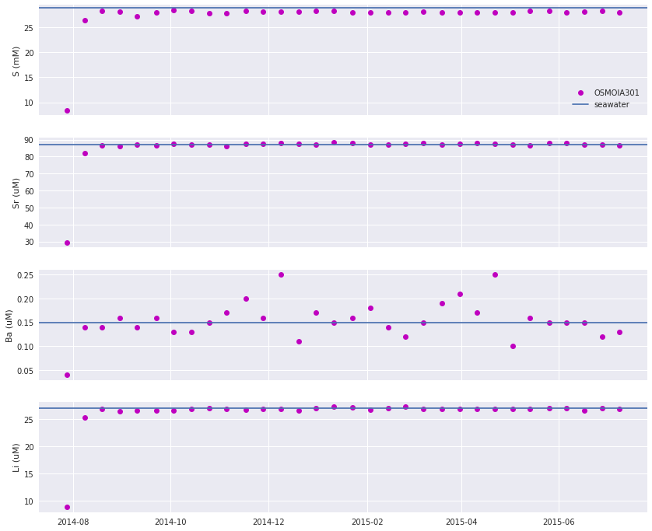

Fig. 5. Sulfur, strontium, barium and lithium contents in water samples collected by OSMOIA301. Trends are similar to those in Fig. 4. The profile for barium shows more scattering as it is at the sub-micromolar level

The results demonstrate that most concentration data are at seawater values. The first two samples are significantly more diluted than the rest of the samples. No obvious hydrothermal fluid (e.g., higher Li and Ca than seawater) is observed.

Possible explanations on why samples resemble seawater are:

* during the sampling period, the water sampler collected seawater at the bottom of the water column. Hydrothermal fluid was not collected at times of sampling; or
* there were leaks in the sample holders and hydrothermal fluid collected was washed away by seawater leaking into the holders

The first two samples show lower concentrations than seawater than the rest of the samples. This pattern is not caused by hydrothermal fluid (e.g., samples have less Li and Ca than seawater while hydrothermal fluid has higher). Therefore the phenomenon may be explained by:

* It took time for the instrument to equilibrate with the surrounding environment. If so, the time it took was about 23 days; or
* The samples were diluted. Perhaps there was still deionized water in the sampler, or there was an error during analysis.

We will look into the above possibilities more in the next section. Further confirmation can be done by gathering data from multiple deployments and carrying out isotope analyses (seawater and hydrothermal fluid have distinct isotope compositions).

### Comparing data from OSMOIA301 and OSMOIA101

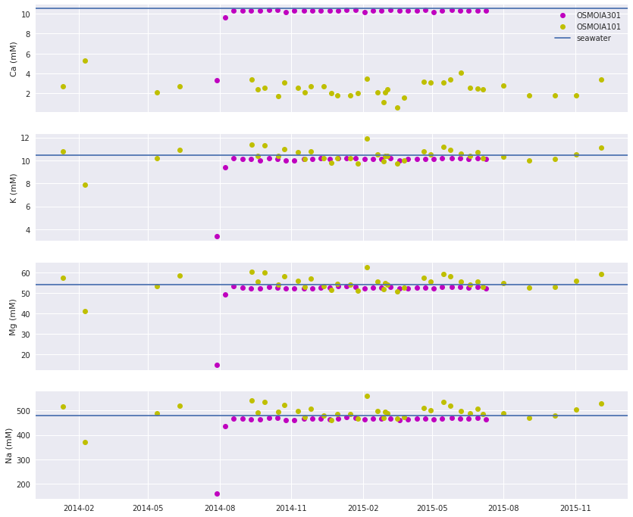

Fig. 6. Comparing calcium, potassium, magnesium and sodium contents from OSMOIA301 (ASHES vent) and OSMOIA101 (Southern Hydrate Summit 2).

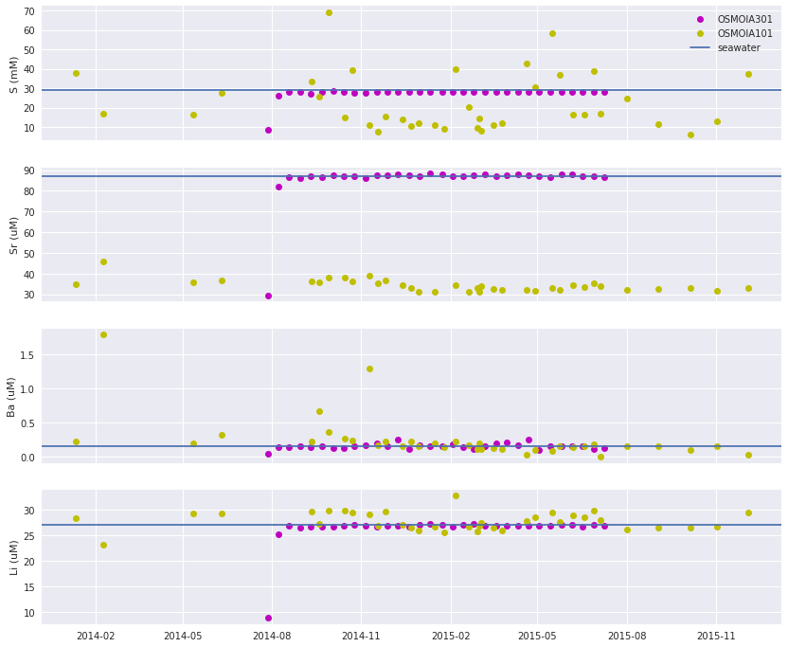

Fig. 7. Sulfur, strontium, barium and lithium content from water samples collected by OSMOIA301 and OSMOIA101

Unlike results from OSMOIA301, the first few samples of OSMOIA101 does not record concentrations significantly different from the rest of the samples. This suggests that instead of the water sampler requiring time to equilibrate with the surroundings, the first two samples from OSMOIA301 were accidentally diluted.

Comparing to OSMOIA301, OSMOIA101 records Ca and Sr significantly and steadily different from seawater values. Ca content from seeps at Southern Hydrate Summit 2 can be lower than the seawater value as Ca reacts with dissolved inorganic carbon below the seafloor. Thus the data here suggest that OSMOIA101 was functioning well in collecting fluid at Southern Hydrate Summit 2.

### Comparing data from FLOBNC101 and OSMOIA101

At Southern Hydrate Summit 2, FLOBNC101 and OSMOIA101 were deployed in close proximity (Fig. 3). Therefore the two instruments should sampled fluid with similar compositions.

FLOBNC101 was deployed both in 2013 and 2014. During the first deployment from Jul 2013 to Aug 2014, no flow was recorded by FLOBNC101. Two coils in FLOBNC101 sampled high concentrations of tracers. The concentrations of most dissolved species measured were about 0. The only exception is sodium with concentrations about 100 mM higher than seawater values, which may be due to the sodium added into the tracer or in the pump. Therefore, in the following, we only compare results from the second deployment (the 2014 deployment) of FLOBNC101 to results from OSMOIA101. Among the two coils of FLOBNC101, we use data from the lower coil so results are not affected by dilution due to tracer solution.

Comparing results from the two instruments (Fig. 8), it can be observed that:

* water samples from the two instruments had considerably different concentrations of Ca and Ba. FLOBNC101 recorded higher concentrations than OSMOIA101. Not only are the concentrations from the two instruments different, the trends of their results are also different;
* for other dissolved chemicals, results from the two instruments are similar, with OSMOIA101 data showing more scattering. Such scattering is more than the normal range. Sulfur (as sulfate) from seep fluid, for example, is expected to be below seawater level (Claypool et al., 2006). OSMOIA101, however, collects some samples that have twice as much sulfur as seawater. Records of how samples were stored after retrieval and just before analysis may provide hints to whether evaporation caused the scattering; and
* the first few water samples from FLOBNC101 recorded lower concentrations of dissolved chemicals than the rest of the samples. Similar to OSMOIA301 (section 4), this may be due to the sampler taking time to equilibrate with the surroundings, or the samples were unexpectedly diluted. If equilibration is the case, the time it takes for such equilibration is about one month.

It remains inconclusive which instrument better samples bottom fluid. While FLOBNC101 provides more steady results, its first few samples deviate from the rest of the samples. The trends of Ca and Ba from OSMOIA101 and FLOBNC101 are also markedly different.

Suggestions:

* check procedures of sample storage, handling and analysis to avoid prolonged exposure of samples;
* check results from multiple deployments systematically to see if the problems above persist, especially for Ca and Ba; and
* based on the data presented in this report, samples collected in the first month after deployment should not be used

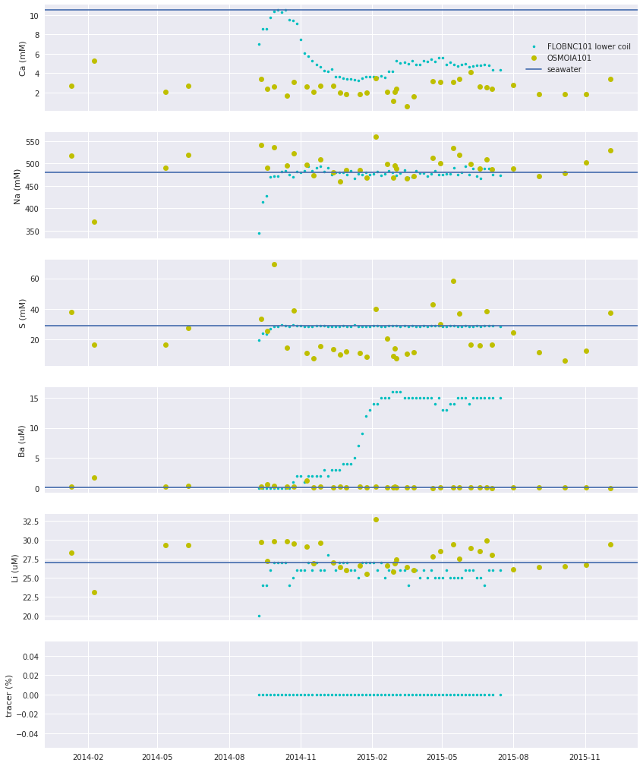

Fig. 8 Comparing chemical concentrations from water samples collected by FLOB2014 and OSMOIA101 which located close to each other

### References

Claypool, G.E., Milkov, A.V., Lee, Y.-J., Torres, M.E., Borowski, W.S., and Tomaru, H. (2006). Microbial methane generation and gas transport in shallow sediments of an accretionary complex, southern Hydrate Ridge (ODP Leg 204), offshore Oregon, USA. In Tréhu, A.M., Bohrmann, G., Torres, M.E., and Colwell, F.S. (Eds.), Proceedings of Ocean Drilling Project, Scientific Results, 204, 1-52.

OOI. (2018a). Osmosis-based water sampler. Ocean Observatories Initiative. url: https://oceanobservatories.org/instrument-class/osmoi/. Retrieved: 3 Aug 2018.

Tryon, M. (2013). OOI CAT meter operation and maintenance manual. Ocean Observatories Initiative. url: https://rawdata.oceanobservatories.org/files/RS01SUM2/MJ01B/FLOBNC101/CAT_Meter_Manual_2013a.pdf. Retrieved: 3 Aug 2018.

University of Washington. (2015). Cabled Array Cruise Plan R/V Thomas G. Thompson and ROV ROPOS TN326. University of Washington for the Ocean Observatories Initiative.